**Analysis and Prediction of Residential Property Prices: A Case Study of Ireland, Canada, and India**

**Introduction**

Residential property prices play a pivotal role in reflecting a nation's economic status and providing valuable insights into the overall condition of its real estate industry. The global construction sector has witnessed significant growth in recent years, with numerous countries experiencing notable advancements in their real estate markets. This study aims to analyze and forecast residential property prices in three different economies, namely Ireland, Canada, and India, considering the diverse factors that influence real estate prices.

The construction industry in Ireland has undergone remarkable growth and transformation in recent times. The Irish Construction Industry Federation (2019) reported that this sector has steadily expanded, contributing significantly to the country's economic development. Consequently, the Irish residential market, like many property markets in Western economies, has encountered an upswing in housing price inflation due to the impact of the COVID-19 pandemic. According to the Bank of International Settlements (2021), global housing prices witnessed a 4.5% annual increase in the second quarter of 2021, marking the highest rate since the Great Financial Crisis (GFC). In real terms, global housing prices now surpass their immediate post-GFC average levels by 24.5%. Notably, the demand for residential properties in Ireland has remained strong since 2013, with real housing prices experiencing significant growth of 94% during this period (Egan and McQuinn, 2022). This price surge coincides with an ongoing international debate regarding whether an increased housing supply can lower housing price inflation (Egan and McQuinn, 2022). Therefore, this study examines and compares residential property prices in Ireland, Canada, and India to determine if Ireland's prices are higher.

**Hypothesis**

The primary hypothesis of this study is that residential property prices in Ireland are higher than those in Canada and India. This hypothesis is based on various underlying factors, including demographic characteristics, supply and demand dynamics, economic growth rates, and government policies influencing the real estate market. Previous research has indicated that Ireland's property prices have been relatively high compared to other countries, making them a relevant subject for investigation (Li and Chau, 2016; Fitzpatrick and McQuinn, 2007). Hence, Ireland is anticipated to exhibit higher residential property prices when compared to Canada and India.

The secondary hypothesis suggests that the accuracy of residential property price predictions will vary across the three countries due to the distinct nature of their real estate markets. Tsatsaronis and Zhu (2004) emphasize that house prices generally depend on factors such as inflation, the yield curve, and bank credit while considering national differences in mortgage markets. House prices tend to be more sensitive to short-term rates in regions where floating-rate mortgages are widely used, and more aggressive lending practices are associated with more substantial feedback from prices to bank credit. Therefore, the complex and dynamic nature of Ireland's real estate market, influenced by factors like credit availability and housing supply-demand imbalances, poses challenges for accurate predictions. Thus, predicting residential property prices in Ireland is expected to be different and more challenging compared to Canada and India.

**Literature Review**

A substantial body of literature explores the relationship between housing prices and the level of housing supply. For instance, there has been recent debate regarding the persistently high housing prices in the UK market over the past two decades. Scholars like Miles and Monro (2021), Wren-Lewis (2020), and Mulheirn (2019) argue that the low-interest rate environment prevailing globally during this period has primarily contributed to the elevated prices. When coupled with consistent growth in income levels, low-interest rates have increased affordability among potential homebuyers, thereby driving up housing prices. However, an opposing perspective presented by Cheshire and Buyuklieva (2019) suggests that the relatively low levels of home construction in the UK market over the same period explain the higher housing prices. In their analysis of how housing supply restrictions, mortgage credit constraints, and price-to-price feedback loops affect housing price volatility, Anundsen and Heebøll (2016) conclude that tighter supply restrictions result in more significant housing price booms and busts.

**Research Gap**

This study addresses a research gap by conducting comparative analysis and predicting residential property prices in Ireland, Canada, and India. While some studies have examined residential property prices in individual countries, a lack of comprehensive research directly compares these three countries. The study aims to provide valuable insights into the similarities, differences, and underlying factors influencing residential property prices in these diverse economies by addressing this gap.

Additionally, the research seeks to bridge the gap regarding predictive accuracy across countries. Although numerous studies have utilized predictive models to forecast residential property prices, the accuracy of these models may vary based on the specific characteristics of each country's real estate market. This study will contribute to a deeper understanding of the challenges and variations in predicting residential property prices across different contexts by evaluating and comparing the predictive accuracy in Ireland, Canada, and India.

**Methods**

This research employed various methods to analyze and predict residential property prices, including descriptive statistics, visualizations, and linear regression. Descriptive statistics were used to calculate the mean and standard deviation, providing a comprehensive overview of residential property prices in Ireland, Canada, and India. Previous studies, such as the one conducted by Alqaralleh and Canepa (2020), successfully employed descriptive statistics to examine housing market trends and price fluctuations.

Visualizations, such as bar graphs, were utilized to visually represent the data, facilitating a better understanding of residential property price trends in the three countries. Visualization techniques have proven effective in conveying complex information in a more accessible and understandable format, as demonstrated by a study conducted by Fan et al. (2019).

Linear regression analysis was conducted to develop predictive models for residential property prices in Ireland, Canada, and India. These models incorporated historical data on property prices, demographic variables, and economic indicators. Statistical methods were employed to assess the accuracy of the models. Linear regression has been widely used in similar studies to predict housing prices and evaluate the impact of various factors on property values (Li, 2022; McMackin and Salter-Townshend, 2018).

**Data Sets**

This research paper used 3 datasets from Ireland, Canada, and India.

1. **Canada data**

The data contain house information from Toronto in Canada. It was obtained through the following link.

<https://www.kaggle.com/code/kerneler/starter-toronto-apartment-rental-price-ddc9c09e-6/input>

Variables



The dataset had 7 columns. The following list represent the description of each variable.

* Bedroom- The number of bedrooms per house.
* Bathroom- The number of bathrooms per house.
* Den- Whether the house has a den or not (1 = yes, 0 = no)
* Address- The location of the house.
* Latitude- The latitude coordinates of the house.
* Longitude - The longitude coordinates of the house.
* Prices- The cost of renting a house

1. **India data**

The data contain house information from India. It was obtained through the following link.

<https://www.kaggle.com/datasets/iamsouravbanerjee/house-rent-prediction-dataset>

Variables

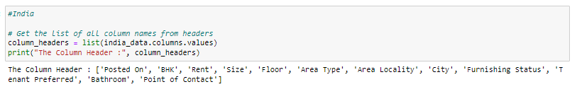

The dataset had 12 columns. The following list represent the description of each variable.

* Posted on. The day the house was posted.
* BHK. The total number of bathrooms, kitchens and halls.
* Rent. The cost of the house
* Size. The size of the house in square feet’s
* Floor. The total number of floors and the floor number of the house.
* Area type. The size of the house
* Area locality. The location of the house
* City. The city where the house is located
* Furnishing status. The furnishing status. i.e. either furnished, semi-furnished, or unfurnished.
* Tenant Preferred. The type of tenant preferred by the house owners.
* Bathroom. The number of bathrooms in that house.
* Point of contact. The person to be contacted regarding the house.

1. Ireland

The data contain house information from Dublin. It was obtained through the following link.

<https://www.kaggle.com/datasets/d17129765/predicting-dublin-rental-daftie>

**Variables**

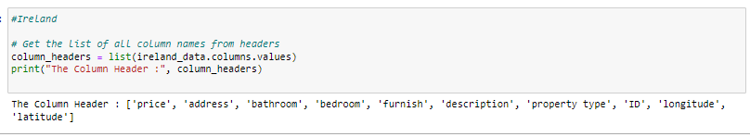

The dataset had 10 columns. The following list represent the description of each variable.

* Bedroom. The number of the bedroom in the house.
* Bathroom. The number of bathrooms in the house
* Furnish. The furnishing status. i.e., either furnished, semi-furnished, or unfurnished.
* Description. The house description.
* Property type. The type of property
* ID. The ID of the house
* Longitude - The longitude coordinates of the house.
* Latitude. The latitude coordinates of the house.
* Prices- The cost of renting a house
* Address. The address of the house.

**Results**

1. **Ireland**

Table 1 below presents the mean price as depicted by the study on residential properties in Ireland as €2,154.28, with an average of 2.04 bathrooms and 1.56 bedrooms.

The standard deviation of property prices in Ireland was found to be €1,016.80, indicating that prices varied considerably.

Table 1

|  |  |  |  |
| --- | --- | --- | --- |
|  | price | Bathroom | bedroom |
| Count (N) | 2131.00 | 2131.00 | 2131.00 |
| Mean | 2154.28 | 2.04 | 1.56 |
| Std | 1016.80 | 1.08 | 0.83 |

Figure 1.1 below presents frequency in relation to the type of residential property that is, the number of property types in Ireland. As shown by the study, the apartment property type had the highest frequency, followed by the house property type and then the studio property type, while the flat property type had the lowest frequency.

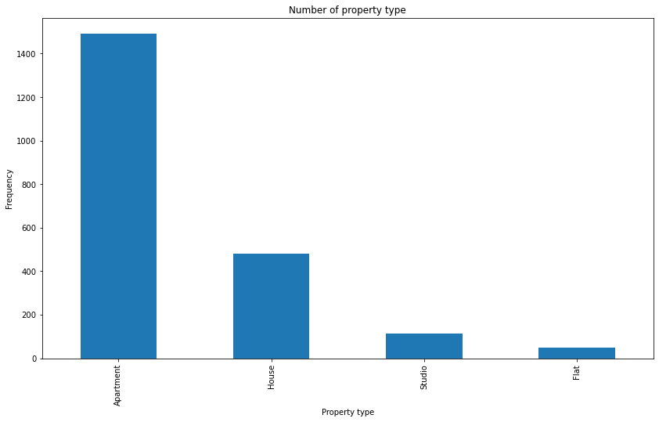

Figure 1.1

Figure 1.2 below shows the frequency of the furnish type of residential properties in Ireland. According to the study, furnished residential properties presented the highest number during the study. Both unfurnished and semi-furnished (furnished or unfurnished) residential properties had low counts but tallied closely. However, semi-furnished properties had the lowest frequency of them all.

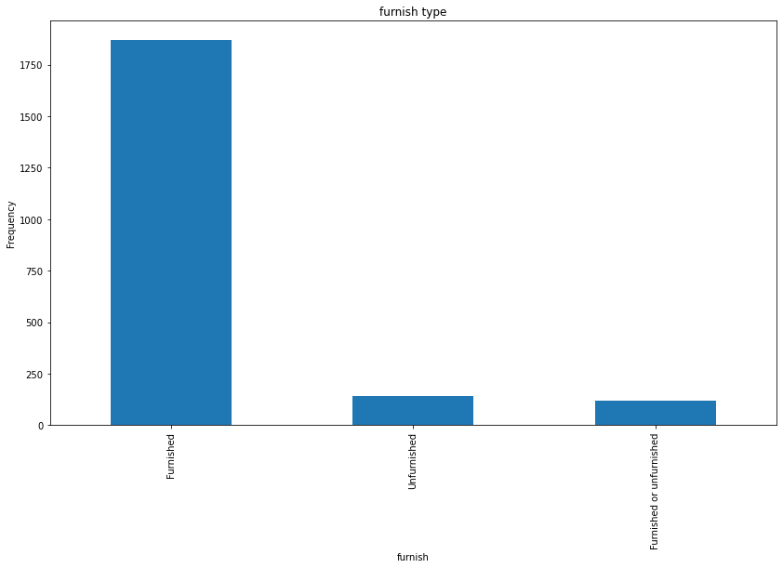

Figure 1.2

Figure 1.3 presents the average price rates of residential properties in Ireland. In terms of average prices, the study found that unfurnished residential properties had the highest average prices in the markets and were closely followed by semi-furnished (furnished or unfurnished) properties in the same markets. Furnished residential properties, however, had the lowest average prices.

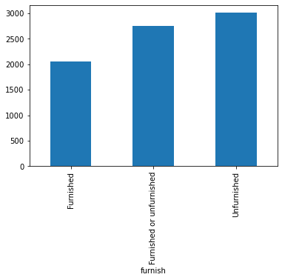

Figure 1.3

Figure 1.4 presents the property type pricing of residential properties in Ireland. The study found that the House property type had the highest average prices, followed by the apartment property type and then the flats property type. In the same study, studio property type was found to have the lowest average prices in the markets.

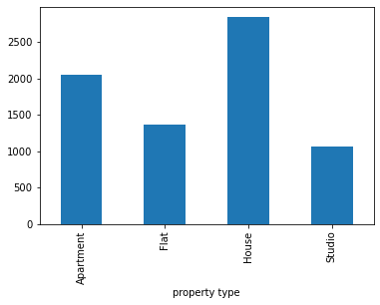

Figure 1.4

Figure 1.5 presents the average prices of bedroom units of residential properties in Ireland. Residential properties with 6-bedroom units had the highest average prices, followed by those with 7-bedroom units, 5-bedroom units, 4-bedroom units, 3-bedroom units, 2-bedroom units, and then 1-bedroom units consecutively. Those with no-bedroom units were found to have the lowest average prices.

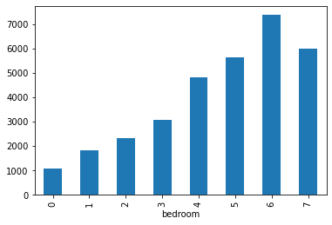

Figure 1.5

Figure 1.6 illustrates the average prices of bathroom units of residential properties in Ireland. The study presented those residential properties with 9-bathroom units had the highest average prices, followed by those with 6 units, then 12 units, 5 units, 7 units, 4 units, 3 units, 2 units, and one unit consecutively. Those residential properties that had no bathroom units had the lowest average prices.

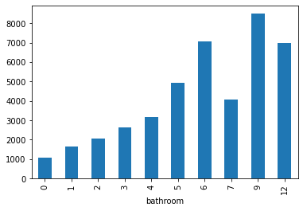

Figure 1.6

**Model**

The linear regression model for predicting price in Ireland used the variables Bathroom, Bedroom, furnished, and property type. As indicated by the R-squared value (0.436), the model accuracy suggested that these variables explained 43.6% of the variation in property prices in Ireland.

**2. Canada**

Table 2 shows that the mean price found by the study on residential properties in Canada is $2,684.65, with an average of 1.37 bedrooms, 1.23 bathrooms, and 0.15 dens.

The standard deviation of property prices in Canada was $20,372.60, indicating that prices varied considerably.

Table 2

|  |  |  |  |  |
| --- | --- | --- | --- | --- |
|  | Bedroom | Bathroom | Den | Price |
| Count | 1124 | 1124 | 1124 | 1124 |
| Mean | 1.37 | 1.23 | 0.15 | 2684.65 |
| Std | 0.55 | 0.43 | 0.36 | 20372.60 |

Figure 2.1 below shows the frequency of den availability in residential properties in Canada. The study found that residential properties in Canada with no den had the highest frequency, while those with a single unit of den presented low frequency.

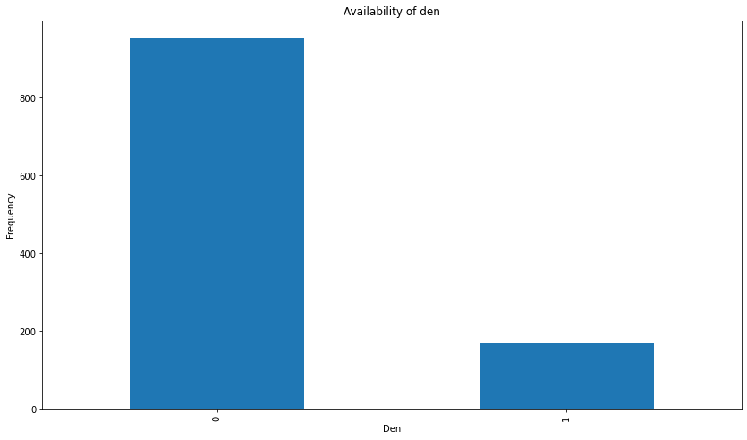

Figure 2.1

Figure 2.2 below presents the frequency of bathrooms in residential properties in Canada. Those with a single unit of a bathroom, as found by the study, were found to have the highest frequency compared to other properties with more than one unit of a bathroom.

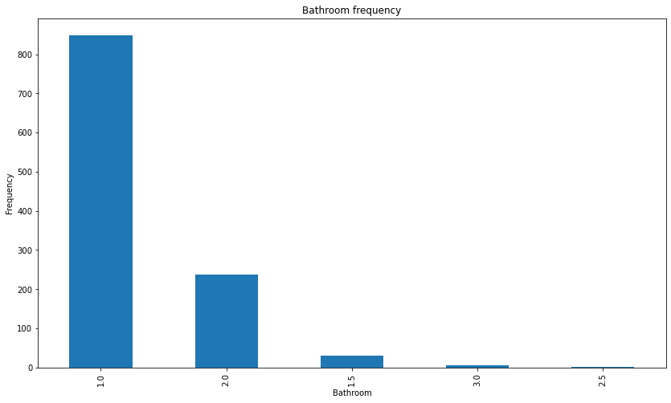

Figure 2.2

Figure 2.3 illustrates the frequency of bedroom units in residential Properties in Canada. The study found that residential properties with a 1-bedroom unit had the highest frequency, followed by those with 2-bedroom units, while those with 3-bedroom units had the lowest tally.

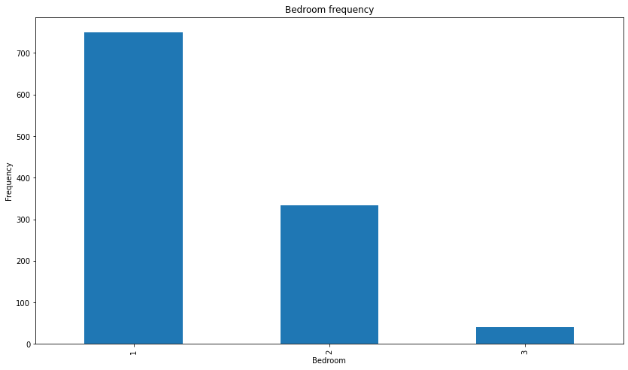

Figure 2.3

Figure 2.4 below presents the average prices of bathroom units of residential properties in Canada. The study found that residential properties with 2.5-bathroom units had the highest average prices, followed by those with a single unit, and then 3 units, and 2 units. Those with 1.5-bathroom units were found to have the lowest average prices.

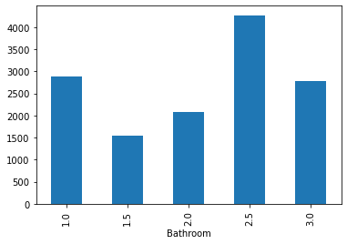

Figure 2.4

Figure 2.5 below shows a presentation of the average prices of bedroom units of residential properties in Canada. Properties with a single-bedroom unit presented the highest average prices, followed by those with 3-bedroom units sequentially. Those with double or 2-bedroom units had the lowest average prices.

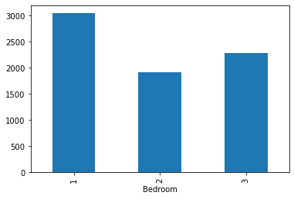

Figure 2.5

Figure 2.6 illustrates the average prices of dens of residential properties in Canada. Properties without a den had the highest average prices, while those with a single den presented the lowest average prices.

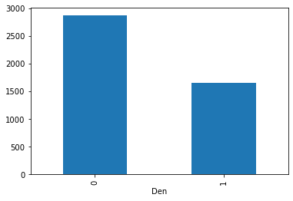

Figure 2.6

**Model**

The linear regression model for predicting price in Canada used Bathroom, Bedroom, and Den variables. The model accuracy, indicated by the low R-squared value (0.001), suggests that these variables have minimal predictive power for determining property prices in Canada.

1. **India**

Table 3 below shows that the mean rent of residential properties in India was INR 419.92, with an average of 2.08 BHKs, 967.49 square feet, and 1.97 bathrooms. The standard deviation of rent prices in India was INR 937.28, indicating that prices varied considerably.

Table 3

|  |  |  |  |  |
| --- | --- | --- | --- | --- |
|  | BHK | Rent | Size | Bathroom |
| Count | 4746 | 4746 | 4746 | 4746 |
| Mean | 2.083860 | 419.921416 | 967.490729 | 1.965866 |
| Std | 0.832256 | 937.276955 | 634.202328 | 0.884532 |

Figure 3.1 presents the frequency of furnishing status of residential properties in India. Semi-furnished properties had the highest frequency, followed by unfurnished and furnished properties consecutively.

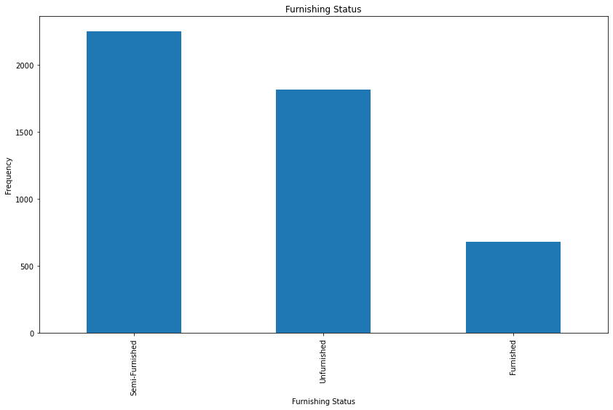

Figure 3.1

Figure 3.2 below shows the frequency of bathroom units in residential properties in India. Residential properties with 2-bedroom units had the highest frequency, followed by those with a single unit, then 3 units, 4 units, and 5 units sequentially. Those with 6-bathroom units had the lowest frequency, as depicted in the study.

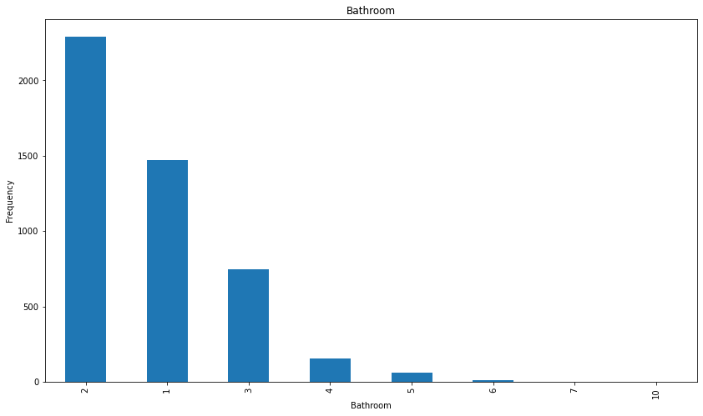

Figure 3.2

Figure 3.3 presents the average prices of furnishing status of residential properties in India. The study found that furnished residential properties had the highest average prices, with semi-furnished properties following the ranking of average prices presented, and unfurnished properties had the lowest average prices.

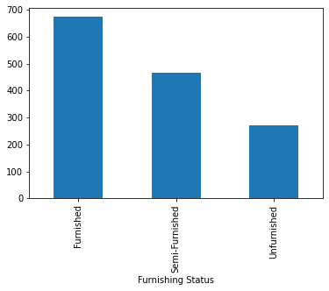

Figure 3.3

Figure 3.4 illustrates the average prices of bathroom units in residential properties in India. Residential properties with 5-bathroom units presented the highest average price, followed by 10-bedroom units, then those with 6 units and 4 units, 7 units, 3 units, and 2 units sequentially. Those with a single-bathroom unit had the lowest average price.

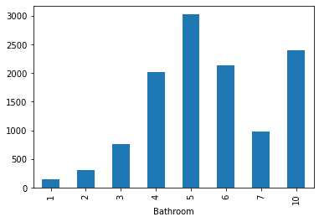

Figure 3.4

**Model**

The linear regression model for predicting price in India included variables such as Bathroom, Furnishing Status, BHK, Size, Floor, Area Type, and Area Locality. The model accuracy, indicated by the R-squared value (0.2372), suggested that these variables explained 23.72% of India's property price variation.

**Summary and Conclusion**

The research focused on analyzing and predicting residential property prices in Ireland, Canada, and India. In Ireland, the study found that the average price of properties was €2,154.28, with significant variations in prices. Apartments were the most common property type, while furnished properties had higher average prices compared to unfurnished ones. House properties had the highest average prices, while studios had the lowest. Additionally, properties with more bedrooms and bathrooms generally had higher average prices. The linear regression model using variables such as bathroom, bedroom, furnished, and property type explained 43.6% of the variation in property prices in Ireland.

Moving to Canada, the research revealed that the average price of residential properties was $2,684.65. Properties without dens had the highest frequency, and those with a single bathroom and 1-bedroom units were most prevalent. However, the linear regression model incorporating bathroom, bedroom, and den variables had minimal predictive power for determining property prices in Canada.

In India, the study found that the mean rent of residential properties was INR 419.92. Semi-furnished properties were the most common, and those with 2-bathroom units and 1-bedroom units were frequently observed. Furnished properties had higher average prices compared to unfurnished ones. The number of bathrooms and bedrooms also influenced the average prices, with properties having more units commanding higher prices. The linear regression model, considering variables such as bathroom, furnishing status, BHK, size, floor, area type, and area locality, explained 23.72% of the property price variation in India.

In conclusion, the research provided valuable insights into residential property prices across the three countries. It highlighted the significance of factors like property type, furnishings, bedrooms, and bathrooms in determining prices. However, the predictive power of the models varied among the countries, with the Ireland model performing better than the models for Canada and India. These findings contribute to a better understanding of the factors influencing residential property prices and can assist stakeholders in making informed decisions in the real estate markets of these countries.

**Word count: 2800 words**

**References**

Alqaralleh, H. and Canepa, A., 2020. Housing market cycles in large urban areas. *Economic Modelling*, *92*, pp.257-267.

Anundsen, A.K. and Heebøll, C., 2016. Supply restrictions, subprime lending and regional US house prices. *Journal of Housing Economics*, *31*, pp.54-72.

Cheshire, P. and Buyuklieva, B., 2019. Homes on the right tracks: Greening the Green Belt to solve the housing crisis.

Egan, P. and McQuinn, K., 2022. Examining the response of house prices to supply using a Markov regime switching approach: The case of the Irish housing market.

Fan, C., Xiao, F., Song, M. and Wang, J., 2019. A graph mining-based methodology for discovering and visualizing high-level knowledge for building energy management. *Applied Energy*, *251*, p.113395.

Fitzpatrick, T. and McQuinn, K., 2007. House prices and mortgage credit: Empirical evidence for Ireland. *the manchester school*, *75*(1), pp.82-103.

Hilbers, P., Oomes, N., & Walton, M. (2008). House price developments in Europe: A comparison. Journal of Housing Economics, 17(3), 235-252.

Li, R.Y.M. and Chau, K.W., 2016. *Econometric analyses of international housing markets*. Routledge.

Li, X., 2022. Prediction and Analysis of Housing Price Based on the Generalized Linear Regression Model. *Computational Intelligence and Neuroscience*, *2022*.

McMackin, L. and Salter-Townshend, M., 2018. Regression Tree Ensembles For Irish Property Valuation.

Miles, D. and Monro, V., 2021. UK house prices and three decades of decline in the risk-free real interest rate. *Economic Policy*, *36*(108), pp.627-684.

Mulheirn, I., 2019. Tackling the UK housing crisis: is supply the answer. *UK Collaborative Centre for Housing Evidence*.

Tsatsaronis, K. and Zhu, H., 2004. What drives housing price dynamics: cross-country evidence. *BIS Quarterly Review, March*.

Wren-Lewis, S., 2020. Evidence and the persistence of mistaken ideas: The case of house prices. Retrieved 17 May 2023 from https://mainlymacro.blogspot.com/2020/ 01/evidence-and- persistence-of-mistaken.html